PS D:\T.E\SEM 6\LABS\SEPM\exp3> git init

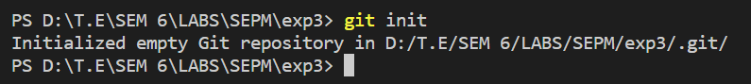Top of Form

initializes a new Git repository in the current directory.

PS D:\T.E\SEM 6\LABS\SEPM\exp3> git clone <https://github.com/divyal-04/test1>

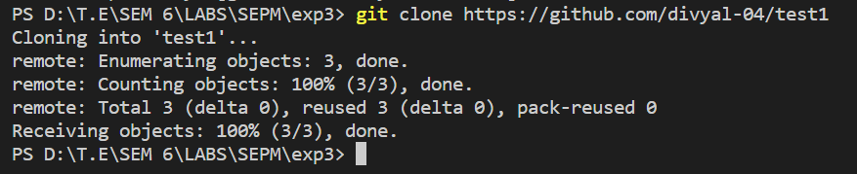

Clones the url repo into the working directory

PS D:\T.E\SEM 6\LABS\SEPM\exp3> git add .

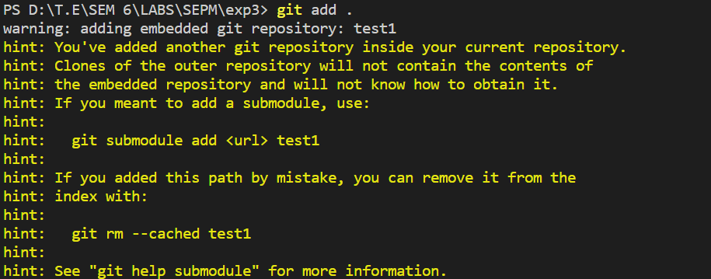

stages all files and directories in the current directory for the next commit.